Cisco CCNA ROUTING & SWITCHING (ICND1)
Assignment
For Learner Use:
Surname of Learner | Naidu
Name of Learner | Kian
Learner ID | 0110105463084
Student Number | KNPMB070
Date of Test Given | 22/11/2021
Location / Branch | iStudent Academy, Durban

For Assessors Use:
Name of Branch | Durban
Name of Facilitator | Mohamed R C Hoosen
Name of Assessor | Mohamed R C Hoosen
Assessor Number | RAS/05/2012/2103
Mark Allocation | 50
Mark Obtained

Competency Status (C / NYC)

Unit Standards | NONE
C&G | NONE

Candidates Signature |  | Date of Submission | 10/12/2021
Assessors Signature |  | Date Marked

Instructions
- Please answer all Questions
- Read questions carefully.
- All practical’s to be done in Packet Tracer and Screenshots must be provided where applicable (if question asks for it)
- Don’t Copy
- Total Marks = 50

Question 1 (Marks 4)
- Identify the below networking devices. Provide the common names.

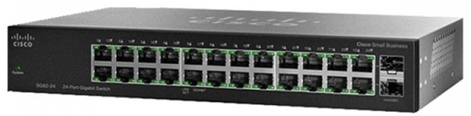

______Switch____________________
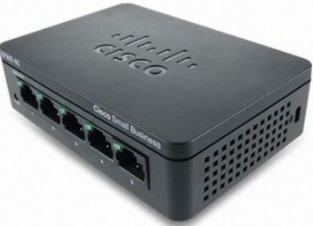
_____Hub________________
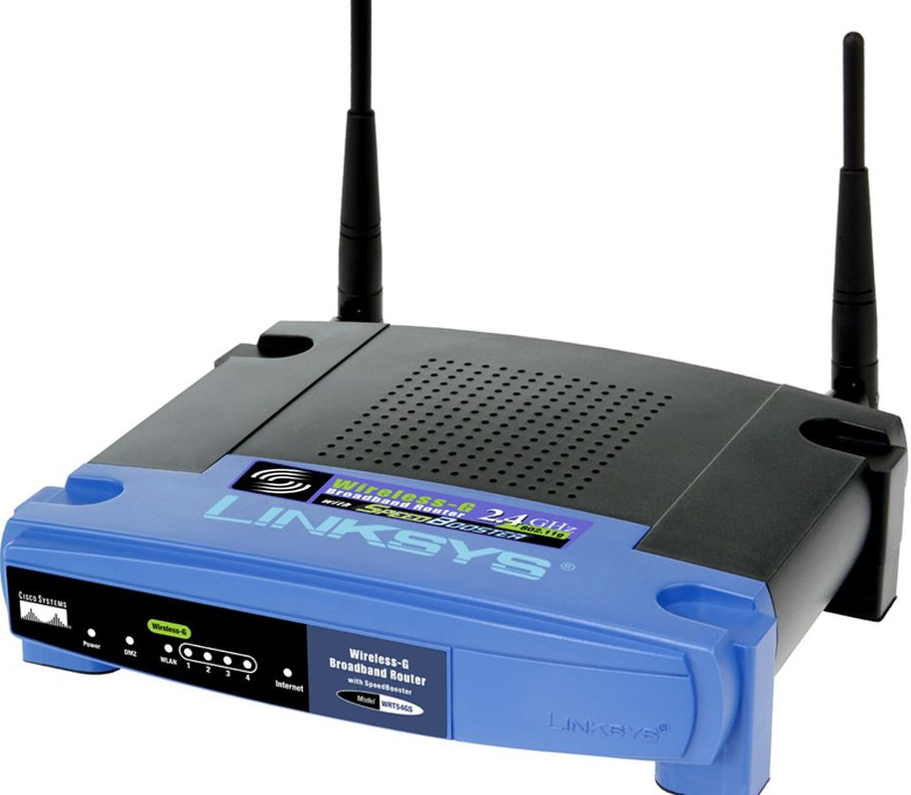

_________Router________________
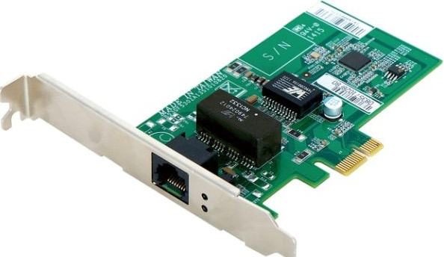
________NIC
(Network Interface card) __________________

- What cable types that can be used between these devices? (Marks 4)

DEVICE | Cable Type Used?
Router to Router | Crossover cable
Switch to Router | Copper straight-through
Switch to Host | Copper straight-through
Host to Router | Crossover cable

- What is the command to turn a router port on? (Marks 2)
(provide a screen shot of the Router CLI)

no shut
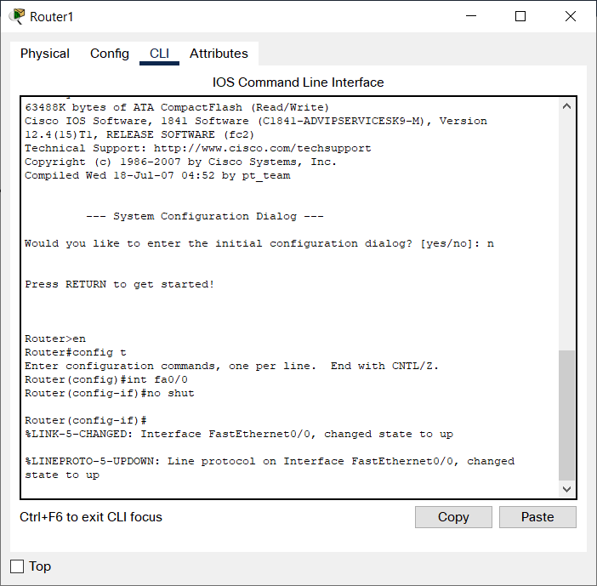

- You are the technician at BonBon Corp, you have been tasked with the following:
(Marks 8)
  - Configure the 2960 switch with the following:
    - Hostname = RouterM
    - Console Password = consolepw
    - Terminal Password = termpw
    - Set a banner message = “Please contact Admin for any errors”
(Provide Screenshots of your config)
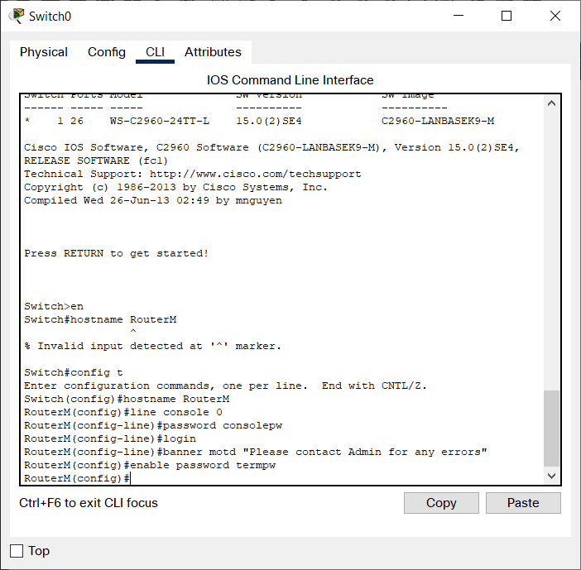

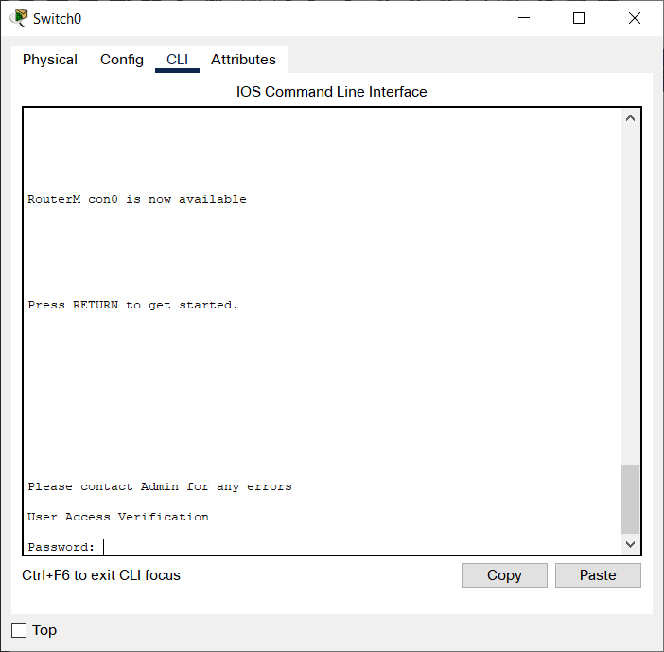
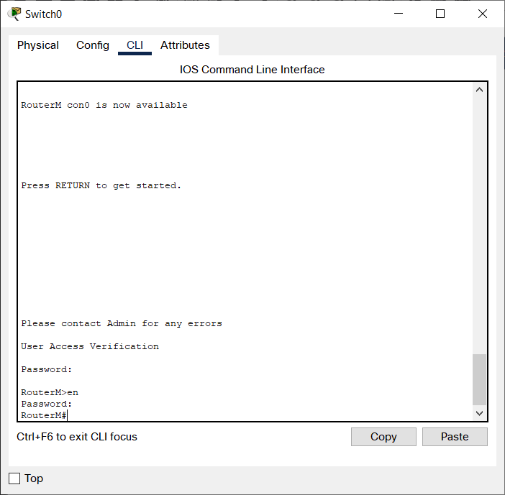

- What is the difference between Layer 2 and Layer 3 Switch? (Marks 6)

A layer 2 switch operates on the layer 2 (data link) OSI model whereas a layer 3 switch operates on the layer 3 (Network layer) of the OSI model. This means that the layer 2 switch can send ‘frames’ to destinations based of the MAC address but the layer 3 switch routes packets with the help of IP addresses.
A layer 2 switch can only work with MAC addresses only but a layer 3 switch can perform the function of both a layer 2 and 3 switch.
A layer 2 switch is used to reduce traffic on local networks whereas a layer 3 switch is used to mostly implement VLAN
Layer 2 switches are quite fast as they do not look at the layer 3 portion of the data packets but layer 3 switches take time to examine packets before sending them to their destination.
Layer 2 switches can only communicate within a network only but a layer 3 switch can communicate with both within and outside the network.
A layer 2 switch has a single broadcast domain whereas a layer 3 switch has multiple broadcast domains.

- You are the technician at Blobworx Ltd, you have been delegated the task to implement static routes, between 2 routers, 2 switches & 2 PC’s. How would you do this task? Below is all info you need to complete this task.
(Provide all explanations & screen shots on how you complete) (Marks 14)

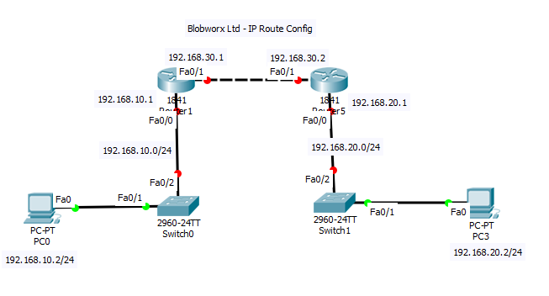

Refer to screenshots folder for images

- Ensure that all the IP addresses are correct on the host devices (Refer to image Question6.1,Question6.2) and that the default gateway is set correctly.

- Check that the routers are connected to the correct ports, that the ports are on and that the ports have the correct IP addresses and subnet masks(refer to images Question6.3 - 6.6)

- Ping PC0 to PC3 and see that you get an unsuccessful reply from 192.168.10.1 saying the host is unreachable to confirm that the network is set correctly. (Image Question6.7)

- Configure the IP routes within the both routers CLI and ensure you type in the correct information for the IP route to be successful (Image Question6.6 - 6.9)

- Ping PC0 to PC3 and you should get a successful reply from 192.168.20.2 to confirm the IP routes work correctly (Image Question6.10)

- You have been given the ip address 192.168.160.150/28. (Marks 8)
Answer the following:
  - What is the broadcast address?
192.168.160.159
  - What is the Network address?
192.168.160.144
  - What is the maximum amount of usable addresses for the first range?
15 usable addresses
  - What is the subnet mask in decimal form?
255.255.255.240

- Explain Briefly 2 types of ipv6 addresse? (Marks4)
Unicast address - A unicast address allows for a point to point connection meaning that data is sent via a one to one basis
Multicast address - A multicast address allows for data to be sent from one device to multiple others.

